EDIT DOCUMENT PARIS TO ISTANBUL 15JUN20   
  
SECTION 2 – BOOK COVER PHOTO IMAGE LEFT SIDE { SKA THIS WAS MY FIRST ATTEMPT AT SQUARE – MAKE PERFECT PLS}  
  
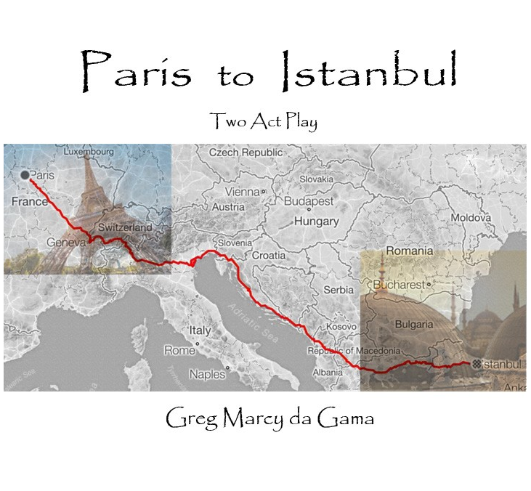

SECTION 2 – FIRST PAGE IMAGE RIGHT SIDE   
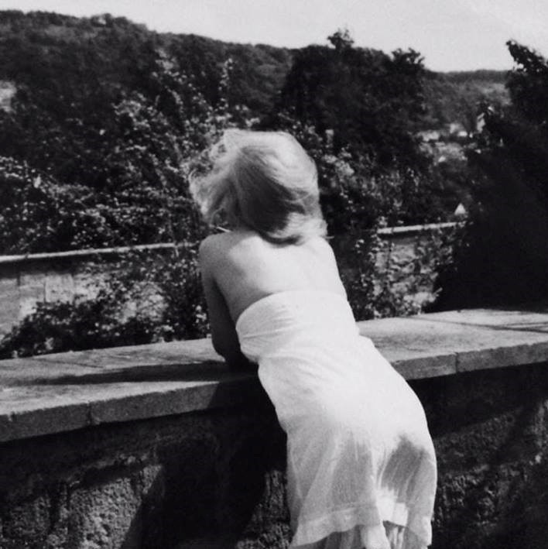  
 Urbana Magellan image anon / osdg (c) mmxx   
SECTION THREE – FULL LEFT TO RIGHT SCREEN IMAGE { NO BACKGROUND BORDER AT ALL ON SIDES   
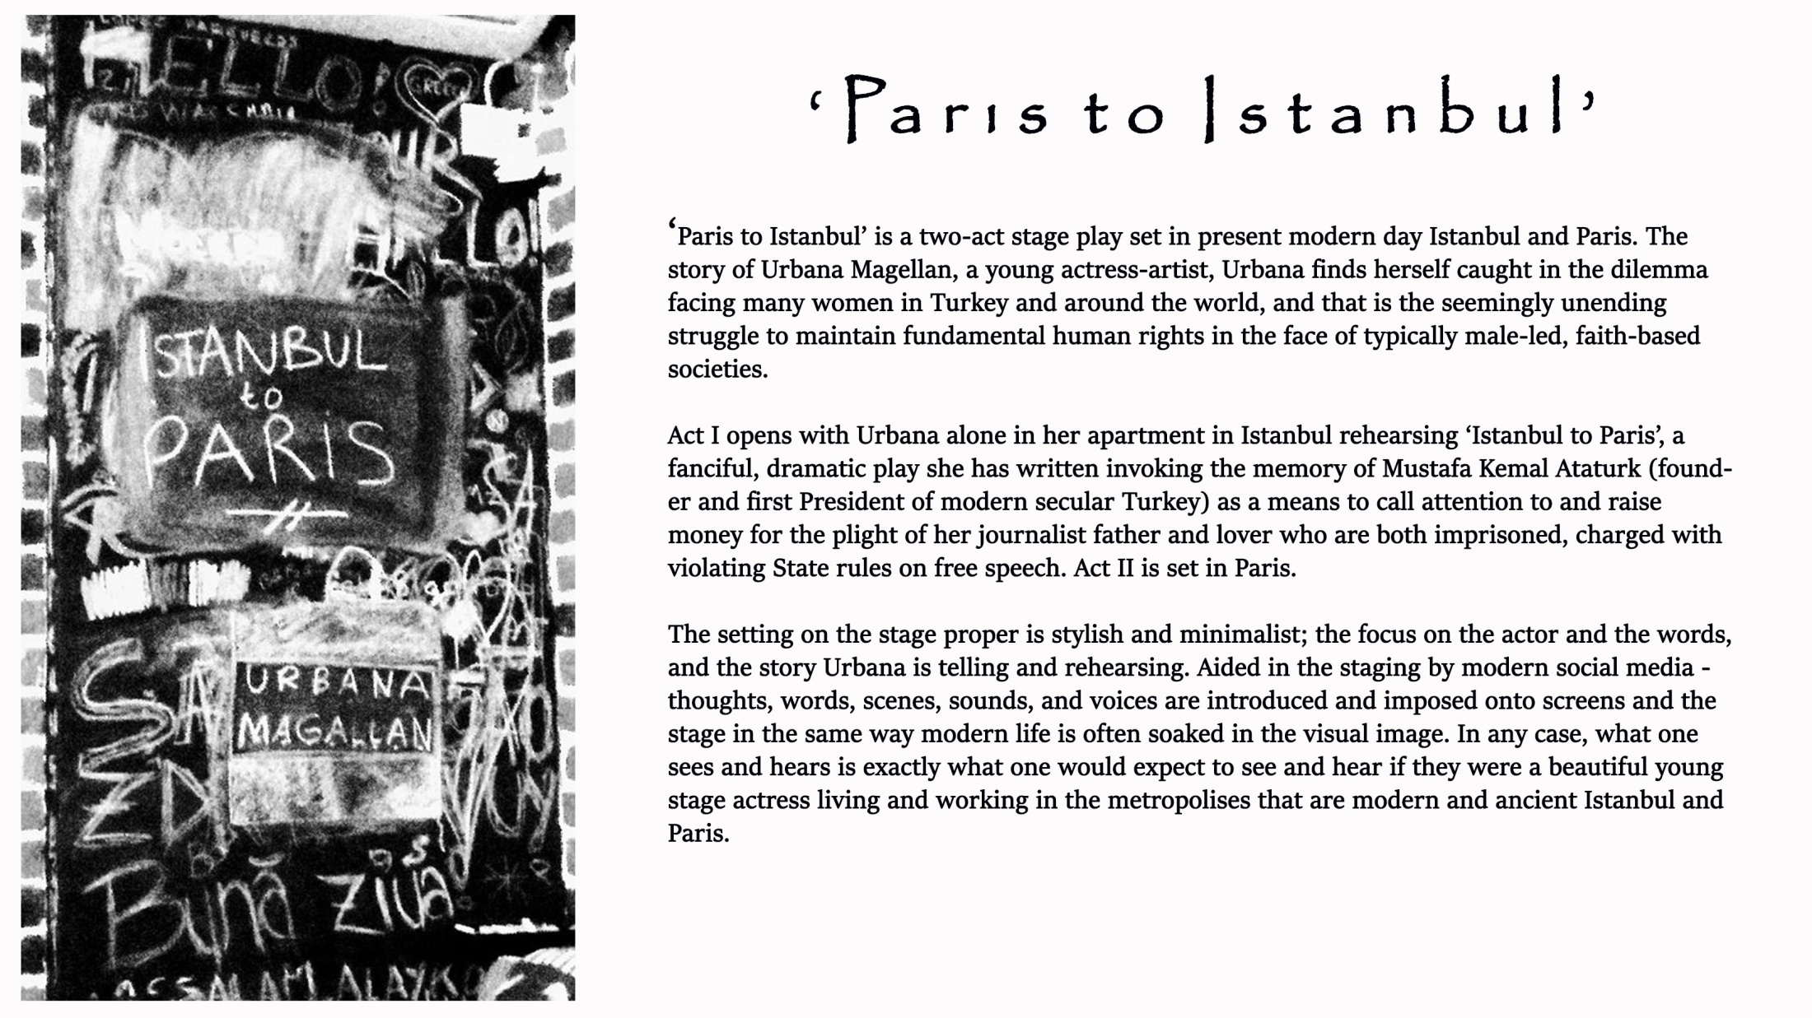

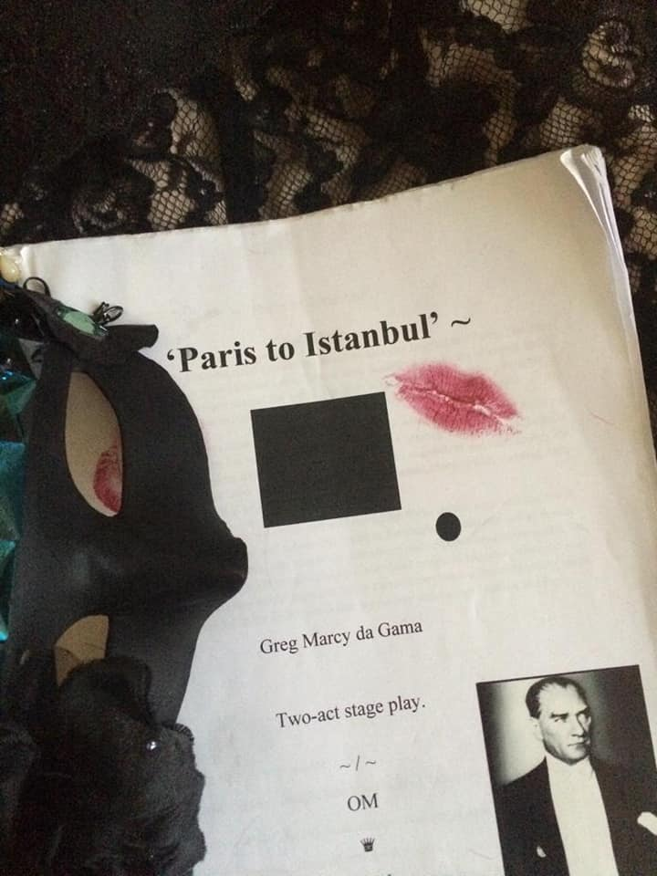

Author Notes

‘Paris to Istanbul’ is a two-act stage play set in present modern day Istanbul and Paris. The story of Urbana Magellan, a young actress-artist, Urbana finds herself caught in the dilemma facing many women in Turkey and around the world, and that is the seemingly unending struggle to maintain fundamental human rights in the face of typically male-led, faith-based societies.

Act I opens with Urbana alone in her apartment in Istanbul rehearsing ‘Istanbul to Paris’, a fanciful, dramatic play she has written invoking the memory of Mustafa Kemal Ataturk (founder and first President of modern secular Turkey) as a means to call attention to and raise money for the plight of her journalist father and lover who are both imprisoned, charged with violating State rules on free speech. Act II is set in Paris.

The setting on the stage proper is stylish and minimalist; the focus on the actor and the words, and the story Urbana is telling and rehearsing. Aided in the staging by modern social media - thoughts, words, scenes, sounds, and voices are introduced and imposed onto screens and the stage in the same way modern life is often soaked in the visual image. In any case, what one sees and hears is exactly what one would expect to see and hear if they were a beautiful young stage actress living and working in the metropolises that are modern and ancient Istanbul and Paris.

~ / ~

Cast

URBANA MAGELLAN – actress-artist

AYSA KARADAM – Urbana’s lifetime best friend; wife of Yaram Kardam. (voice only)  
  
YARAM KARADAM – Chief, Turkish State Security; husband of Aysa Karadam ( voice only )

MEHMET NERGIE – Parisian theatre director ( voice only )

JACQUES DAVID MAGEN ( J. D. ) – Human rights attorney; former lover of Urbana.

Police Officers, Judges, Bailiffs, Protestors, and assorted historical personages (voice / image )

♛

~ Act I, Sc. 1 ~

{ Urbana is dressed in a suit like Chaplin and is made up to look like Ataturk sexy woman. }

URBANA

My name is Urbana Magellan. I am a woman of the 21st century. Do you ‘Like’ me?

{ She looks ahead into the oncoming light }

Do you find me ‘pretty’ ?

Smart ?

Perhaps, even ‘clever’ ?

I thought you might.

{ she blows a little kiss }

. . .

{ she taps her foot – a ballet slipper }

I hail from the City of Lights . . . and now . . . I make my way to center of ‘Discovery’.  
  
Join in, take a spin, here it comes, easy it goes . . .   
  
Whoooooosh!!!!  
  
{ a wink }  
  
{ a nod }  
  
{ opens upturned palms / tilts head }  
  
Why not ?  
  
{ nods n’ smiles, crinkling her eyebrows }  
  
{ puckers he lips – muaaak! }  
  
I want you . . . You want me

That’s the way it’s supposed to be . . .

Right . . . ?

I was born a very long time ago . . . so long ago . . . now, I cannot even remember where it was or to whom, yet, I know it was me, for I am here, you are there, and together, let us go hand in hand . . . Shall we?

{ she extends her open hand and begins a slow turn – music begins . . . soft . . . she begins slow movements; balletic, graceful, she sways, to n’ fro . . . she sings-songs the words }

Here I am . . . Take me now . . . Here I am . . . For you and hooooooooow . . .

{ she dances slowly – again repeating the line }

Here I am . . .

Take me now . . . Here I am . . . For you and hooooooooow . . .

In the beginning was the word

And the name of the word was ‘Ataturk’

‘Mustafa Kemal Atatürk’

Such a strange name! Such a strange man!

But I love him

And for me, Beauty,

Lover of all things light and life

It is enough for and from me,

And from us

Yield forth the truths of Earth’s beauty.

‘Heretic’ – Able to choose.

They chose each other,

And in so doing

Separate, yet, together,

They found their way as One.

Let me tell you a little story

Our little story.

As I said,

It was a long time ago, so long ago now

History cannot seem to even remember when it was!

And that is why ‘Her-story’ has sent me!

Once there was a man of the East and West

And far and wide he was the best,

A human man, not a God,

{ Although of God and the Gods he to well did speak }

And to the people

Of our far great land,

That place where mythical heroes did wander,

Large and Proud,

Then and forever after

He laid course upon the people there,

A simple message of peace.

“ People need two things in life.

Something to believe in, and,

Someone to believe in;

If we are lucky,

Someone may believe in us! “

You see?

You see how smart that is!

My God! Mon Dieu!

Something to believe in!

Someone to believe in!

If luck,

Someone believe in us!

So, now my friend,

Now you see why, I, Beauty,

Grew to love this man.

‘Mustafa Kemal Atatürk’

*Ataturk!*

*Ataturk!*

*Ataturk!*

{ with the heel of her foot - tap! tap! tap! }

***Ataturk!***

***Ataturk!***

***Ataturk!***

Two bits! Four bits! Six bits! A dollar!

All for Ataturk

Stand up and holler!

*Wheeeeeeeeeeeee!!!*

{ she waves upraised hands trembling fingers like electricity is in her – she calms }

Yes,

Now where was I?

Hmmmm . . . .

Let me think.

{ She draws herself up }

O, yes! Ataturk!

{ She paces }

{ She looks out to the audience }

{ Speech 1 of Ataturk }

“ I know who you people are.

And I see what you are doing.

And, I must say,

I am not very pleased.

{ Frowns. Stomps foot. }

Listen!

From the time I was a boy,

Until the time of my passing to the gods,

I devoted my life to giving you,

My people,

Earth’s people since the time of Achilles and Helen,

A chance to live life as free people in our blessed land

With every chance to bridge East and West.

Together,

We were successful in the Turkish War of Independence.

We established ourselves and made great strides

In political, economic, and cultural reforms.

We transformed the Ottoman Empire into a modern, secular nation-state.

Thousands of new schools were built.

Primary education was made free and compulsory.

Women were given equal civil and political rights.

The burden of taxation on our common people was reduced.

And now, my Turkey?

What have you done with those golden opportunities?

With that which we bequeathed to you to treasure?

To nurture?

To make better and to build upon?

To leave a legacy for our children just as we left one for you?

Expand the power of the State over The People

Rather than the power of The People over the State?

Is that what you learned?

Really?!

Really!!

{ His face grows stiff and stern. He stares down his audience. }

{ He does not blink }

{ A ferocious and loud knocking at an unseen door! }

*Rap! Rap! Rap! Rap! Rap! Rap! Rap! Rap! Rap! Rap! Rap!*

{ Ataturk does not break character nor stare }

*Rap! Rap! Rap! Rap! Rap! Rap! Rap! Rap! Rap! Rap! Rap!*

{ Ataturk’s face slowly changes its characters and transforms back into the woman Urbana. }

My God!

{ She slumps and then rushes to the door. }

*Rap! Rap! Rap! Rap! Rap! Rap! Rap! Rap! Rap! Rap! Rap!*

“Police! Urbana Magellan? Open the door!”

{ End of Act I, Scene I }

~ / ~

Act I, Scene II

URBANA

“Who’s there?”

OFFICER

“Office of State Security! Open the door at once!”

URBANA

“Why?”

OFFICER

“What?”

URBANA

“Not ‘What?’ Why?”

OFFICER

“Open that damn door!”

URBANA

“I shall not. You have a warrant?”

OFFICER

“What?! A warrant?! I don’t need a warrant to speak with you!”

URBANA

“Yes, you do. I am a citizen of Turkey. Child of Ataturk!”

OFFICER

“What?! Ataturk?!”

URBANA

“You heard me. I am child of Ataturk. Now go away.”

OFFICER

“Open that goddamned door or I will come back with others and we will break it down!!”

URBANA

“Suit yourself. I am citizen of Turkey and child of Ataturk. Do you understand?”

OFFICER

“Stop saying that! Are you mad?!”

URBANA

“Yes. I am mad. Quite mad. Now be off with you!”

OFFICER

*Rap! Rap! Rap! Rap! Rap! Rap! Rap! Rap! Rap! Rap! Rap!*

{ Urbana walks slowly away returning to her make-up mirror.

She sits quietly staring and assessing her state of person and mind.

She is both shaken and stirred yet of steely resolve and slight tremble.

She is very proud of herself.

The knocking on the door subsides.

Footsteps recede in the hallway.

Neighbors are heard talking in the background.

The window lies open.

Sounds of the street and night.

Lights of cars, ambulances, police.

Slow, smoky jazz music.

She stands, facing the audience. }

URBANA

I am Urbana Magellan. I am a woman of the 21st century. Do you ‘Like’ me?

{ She looks ahead into the oncoming light }

Do you find me ‘pretty’ ?

Smart ?

Perhaps, even ‘clever’ ?

I thought you might.

{ she blows a little kiss }

{ she winks }

Let us continue.

{ she loudly taps her foot a la Ataturk }

ATATURK

“You see what you have done with this precious liberty I fought to give you?

Now even our women are not safe in their homes.

In their homes!!

{ she spits }

{ examines her top hat }

{ weighing it carefully – as if it were the cradle of human rights }

Look.

Let me explain something.

“To have a Nation you must have a consensus – a shared value system.”

{ she lifts her hands and cups each of her breasts from under }

{ first the left / then the right }

“You have the Church. / You have the State.”

“Never in the mouth at the same time. Understand?”

{ she pushes one to to the left / the other to the right }

“Always separate. Understand?”

All Individuals are Endowed by Their Creator

With Two, Imperative, Twin Wills To Power:

The Will to Consciousness & The Will to Expression.

These Twin Wills are Innate Human Rights.

Each of These Human Rights Carries Sustaining Responsibilities.

These Twin Wills Are Worth Protecting With Our Live’s.

With our lives!!

~ / ~

“Humanity’s Power of Consciousness & Expression”

If so many exquisite qualities of Humanity

- conscience, free will, our twin wills to power -

were hardwired by nature and the gods into our very beings,

would we not then benefit as Individuals,

and Individuals within our larger Groups,

to express our conscious activities,

that is to say,

our social, political and economic affairs,

in ways that more harmoniously reflect

these exquisite and innate human qualities?

Is that not our right as free willed Individuals in an allegedly democratic society?

If in so doing,

we do not infringe on the precious democratic rights of another citizen,

do we not have the right,

and can we not effect

mores, customs, attitudes, and, yes, even laws,

that demonstrate a commitment of Individuals

to themselves and to each other?

Can we Assert our Will to Power a Common Destiny?

Will we acknowledge as Individuals

Our allegiance to each other?

Will we learn that

In Serving Others, We Serve Ourselves?

If so,

We will Discover for Ourselves

A common moral and cultural code

That can serve as the basis

For a continued and sustainable Legacy.

{ she lifts her hands and cups each of her breasts from under }

{ first the left / then the right }

“You have the Church. / You have the State.”

“Never the two together. Understand?”

~ / ~

“Let me tell you a little story . . .

“A long time ago, so long ago it seems like I was only a girl – well – in fact, I was just a girl!

{ giggles }

I am the daughter of a rich and powerful man.

But you already know that, don’t you.

Of course you do.

My father resides in your jail.

As well as does my lover.

You would like to be my lover . . .

Wouldn’t you ?

{ she spits }

O, yes . . .

Where was I?

Yes.

I was a girl.

And I had a friend.

A very good friend.

Her name is Asya – her name means ASIA.

She is beautiful Turkish girl.

Her father was an Iman.

Naturally, she was raised as a Muslim.

“Muslim.”

What does that even mean?

Me.

An actress.

A woman who goes onto the stage and bears her heart and soul

So that others might have some idea of what beats in hearts and minds of others.

This was and is my sin.

As children we were very close.

My father was not a prejudiced man.

He was a successful business man.

He ran one of our great newspapers.

He was its editor and with his partners, its publishers.

I am and have always been very proud of my father.

Of his enemies,

And trust me,

One does not have newspaper in Turkey without having enemies!

{ she spits }

And his crime?

{ she spits }

We will return to that.

Now . . . about Asya.

We are in school together.

It is Fall. The air is cool. We can sense a hint of winter!

It is fun! It is October!

We are in the schoolyard.

We are playing! We are children! We are girls!!

Can you see us?

Can you see how happy we are!

Our cheeks are pink and our smiles are wide!

And then he comes.

Him.

Him!

Not really him.

He sends someone instead. For him.

But it is still him!

Him!

The Iman.

She.

She walks towards us on the playground.

She is tall. Dark. Hajib.

She walks sturdy and strong with a purpose.

Her purpose?

Us. To separate us.

Two children.

One of the Church. One of the State.

Children!

Daughter of a writer / free thinker.

Daughter of cleric / misogynist.

Him!

You could see Him! In Her!

In the eyes!

She was coming for us.

Him!!

{ she spits }

{ a phone rings }

{ Urbana slowly devolves from her trance - she sees the screen is a call from Paris }

“Hallo? Bon soir.”

MEHMET NERGIE  
  
“Urbana? Mehmet! We are ready for you! You will leave tonight?”  
  
URBANA

Mehmet! Ah, oui! I am ready!. Merci! Just a few ‘small things’ to take care of.

MEHMET NERGIE

“Merci, au toi, Urbana. I know these are difficult times. Be careful.”

URBANA

Careful is my aim.

{ lights down }

End of Act I, Scene II

~ / ~  
_________________________________________

Act I, Scene III  
  
{ stage lights up }  
  
URBANA

Let me tell you a little more about who it is I am.

Why I am even dressed like this.

{ Her hands caress the lapels of her smoking jacket – At the collar she turns it up. }  
  
{ She takes out a cigarette pack and lighter from her jacket. Lights up. Returns them to jacket. }

I told you – I am an actress.

‘Do you ‘Like’ me?

{ Cigarette dangles from the side of her lips }

{ She opens a bit of her collar and buttons showing her cleavage. }

‘Of course you do! What’s not to like?

{ she giggles – then a fierce frown – yanking the cigarette from her mouth }

Don’t play stupid!

I’m not just an actress.

I am also a writer, and writing is my first and foremost passion. It is in words, whether Ataturk’s, or mine, Shakespeare’s, or Rumi’s, in words we find our universal truths.

Here is a universal truth. The government of Turkey is corrupted by religious influences.

That is no secret. If it were not, you would not even be here to see me, now would you?

No, you would not. So, yes, I am a writer – a teller of truths - of that there is no doubt.

To write well is to think well, to think well, is to have studied well. Study I have.

My father and lover both now rot away in our infamous Istanbul prisons!

Our President, him, nothing like Ataturk at all, he makes proud claims of our liberty.

Listen!

It was only this year he remarked that our Turkish journalists were freer than any in Europe!

I wonder now, after he arrested and imprisoned my father and 17 other journalists, charging them with spreading terrorist propaganda - publishing a photo of a legal official held at gunpoint by far-left militants – in other words, showing our people of Turkey the TRUTH of what and how our becoming a ‘religious’ state is harming the secular legacy left to us by Ataturk – I wonder, when he was alone that night in his luxurious home that we pay for, eating the exquisite delicacies of our motherland prepared by the finest chefs that our country can produce, while he dined, yet, my father pissed in the corner of his cell with the others, and having nothing but garbage to eat, do you think, spirit of Ataturk, that perhaps, maybe just a little, as he thought of the why and the hows of his ways, dear, that he choked? Did he choke, dear Ataturk, so that his breath was short? So that he worried for his very life? So that his life passed before his eyes? No?!

{ A wind and rain begin to sound through the open windows. She closes her jacket }

I am sure he did not. I am sure that night my father did choke.

My father, him, like me, a teller of the truth.

{ The sounds of wind and rain pick up. Urbana walks to the windows and closes them. }

{ She returns to the stage center spotlight }

Listen.

I am leaving for Paris tonight.

I told you I was a writer.

Writer, I am.

I have written a little story.

A play within a play.

About an actress from the East who suffers the cruelties of life – much as I do – and who takes to the stage of Paris – a virtual expatriate in her own land – for if I were to tell these stories here in Istanbul – like my father; like my lover, I, too, might likely share the same dark fate as them. This is why I go to Paris. There, in Paris, we have many of our countrymen who under the banner of “*Liberté, égalité, fraternité”*– not “*Egemenlik, kayıtsız şartsız milletindir!* - and where a strong Turkish presence in Île-de-France we are still able to write, speak, and act of our dark truths without fear of prison or harm. This is why tonight, now, I rehearse for it, alone, here in the comfort and quiet of my own apartment. Tonight, I take a train to the West.  
  
<https://www.youtube.com/watch?v=V2fFRlMzzLs>

{ While the music plays, Urbana begins the packing of her valise from the vanity mirror. As the song closes, she opens the final drawer. There she removes a shiny, .38 caliber police revolver.}

URBANA

A gun. Me. A girl and a gun. Why? Why do I have this here? Me.

{ She draws a large circle in the air with the gun. She makes a wide circle with it once. Then, in the other direction, she makes a wide circle again. The gun is now pointed at the floor. She stands silent. Not moving, she is thinking. Lips motionless, body still, the voice of Urbana’s thoughts are slowly heard on the stage. They have a quiet, dreamy tone to them. The way it is when we all think and the moment is captured in solitude. Her heart is heard beating in the background as is also her breathing. We see, feel, and hear Urbana thinking. As she recounts the story of how she came to have her gun, a montage of black and white images slowly and majestically stream across the high screen walls behind and to the sides of her. They are direct and iconic images of the mind’s eye memories she has of the story she is remembering.}

URBANA

It’s funny how I got this gun. Imagine that. Asya, my beloved Asya. ‘Urbana? Listen. I know how hard it is for you now. Your father in prison. Your lover, too. And you are not safe. I know you know that. Listen. I cannot come to you. I can barely even find the time and safe place to call you. But, listen. I have something for you. Something I want you to have. Something you will need. No, it is not flowers, or jewelry, or perfume – none of the things like we think we need. It is a little something that will help the world respect you a little more. And, darling sister, me, all of us, we are counting on you to make the world a little safer for all of us women. Do you understand? Urbana? Listen. I am sending it to you tonight by taxi courier. It’s just a small gift, yet, it has great power. Like you. I must go dear.   
  
“Allah büyük - ama sen de öylesin. Beraber sopa, biz yine büyük olabilir.”

Asya, my darling. Asya. Married to the Chief of State Security! How could it happen?

Him! Him! Him!

Jailer of my father! My lover! And, now, looking to ‘interrogate’ me!

Interrogate!

O, I am sure he would like to ‘interrogate’ me.

{ she spits }

O, Asya was and is such a Muslim beauty.

Yet, what has happened to her life that she can now barely even use the phone in peace.

What strange things overtake our lives.

Life.

It’s what happens to us while we are busy making other plans.

“Asya.”

I will never forget that phone call as long as I live.   
  
{ she holds back tears }

*Rap! Rap! Rap! Rap! Rap! Rap! Rap! Rap! Rap! Rap! Rap!*

*Rap! Rap! Rap! Rap! Rap! Rap! Rap! Rap! Rap! Rap! Rap!*

{ Urbana shouts at the door. Not taking her eyes off the audience }

Who’s there?!

POLICE

Police! Urbana Magellan! Open the door!!

URBANA

Why are there police here?

POLICE

We are here now with the Office of State Security! Open the door at once!

URBANA

Why?

POLICE

Don’t start that! This is no game!!

CHIEF OF STATE SECURITY

Urbana? It’s me.

Yaram Karadam.

Open the door now please.

No one will hurt you.

We have some simple questions for you.

This won’t take long.

If you cooperate with us, it will make it easier.

Easier for everyone.

. . .

I think you know what I mean.

Urbana?

{ She snaps back into reality. Looking left to right. She knows she has the gun in her hand. Effortlessly, she opens her jacket. Into the cumberbun sash she wears at her waist, she slips the gun into it, its handle exposed and ready, easy to be removed. She closes her jacket. Pats the spot where the gun resides. Like a soldier, she spins on her feet in precise movement. She strides confidently to the door.}

URBANA

I am a child of Ataturk! A human! A woman! An actor! Artist! I am proud to have guts! Grace! Courage! Able to say and understand the words and worlds I am writing! Spoken from my heart!

"We Turkish women are strong! Very strong!!

One day . . . You fascist Islamists will be afraid of us!!!  
  
I know, to you, this is all just crazy talk! – But let me tell you!

The story, our story, how women in Turkey – not just Turkey – but all over the world – it is just going to get better and better! Even if you do not think so!

I know what I am doing! I know how far I can push things.

Now listen to me, ‘Yaram Karadam.’

I am going to open that door.

But it does not take an army of security soldiers to ask a woman a few questions, does it?

No, it does not.

Yaram Karadam, send the others away.

Then I will open the door.

Then you can have your time with me.

Do you understand?

{ Sound of men’s voices in discussion can be heard. Quiet. A group of footsteps walk away.}

CHIEF OF STATE SECURITY

{ soft knock }

Urbana?

End of Act I, Scene III

~ / ~

Act I, Scene IV

{ In the white light darkness the cutout shadow of a large man enters the room. Urbana backs up. Compared to her real life figure, the male shadow is twice her size. She speaks to the Shadow of Yarman Kardam. Karadam’s voice speaks to Urbana.}

CHIEF OF STATE SECURITY

Now that wasn’t so hard, was it?

URBANA

What would you know about being ‘hard’.

Have you been ‘hard’ lately?

CHIEF OF STATE SECURITY

Alright. There is no need for such talk.

I am here only to ask you a few questions.

URBANA

Questions? What kind of questions could you possible have for me?

Me. You have my father locked up in your prison for merely publishing the truth.

You have my boyfriend locked up god knows where.

And for what? For screaming at the State that his poor child was shot and now dead for ‘stealing a loaf of bread?’ Is that what you want to ask me about? A fucking ‘loaf of bread?

Wake up, Kara - Adam! Wake up!!

{ The shadow moves slowly and uncomfortably. It stills. }

CHIEF OF STATE SECURITY

Now listen to me, Urbana.

All that is well and good.

You are smart, beautiful woman.

Look at you.

Dressed like some crazy woman.

You are crazy, that is for sure.

Crazy, but beautiful crazy.

Now listen.

If you help us, if you help me, if you cooperate . . .

I can make things easier for your father and for that ‘man’ you call your lover.

Do you understand?

We’ve known each other a long time.

You have chosen to go your own way.

Asya and myself have chosen to go another.

That does not mean that you and I cannot meet together in the middle, does it?

{ The shadow moves closer to Urbana }

URBANA  
  
Stop.

Come no closer.

What is it you are saying to me, ‘Yaram Karadam’.

Tell me. You are man.

What is it you want?

You ‘Like’ me?

Is that it, ‘Kara – Adam’?

You want me?

You need me?

You simply just have to have me, right?

Talk to me . . .

Boy.

{ Disoriented, ‘The Shadow’ moves in strange, uneven ways. Urbana does not move. }

CHIEF OF STATE SECURITY

Stop it.

Stop it!!

I could help you, Urbana.

I could be so many things for you.

I could be of such service to you.

Imagine that!

Your father freed.

The charges lowered against your lov . . . against him,

Someday he could be freed.

{ ‘The Shadow moves closer and now Urbana is engulfed in his shadow. }

This could be for us.

This could be special.

Personal.

Private.

You.

Me.

{ ‘The Shadow moves in and out, over and under, around, by side, through, by, along Urbana The windows blow open. Great winds and rain pour in. Lightening and thunder crackle. The sound of Turkish Arab drums fill the air. Sirens and Gezi Park protest sounds. A beat. A moment. A rush. A dark ambient soundtrack accompanies all. }

URBANA

‘Kara – Adam?

Is that what you came here for?

For us?

For you n’ me?

To have me?

Now, and forever?

Touching.

I . . . I . . . I . . .

Almost don’t know what to say.

Kara Adam.

You would prefer me than your wife?

Asya? My best friend?

Really?

{ Urbana unbuttons her jacket. It opens. She unbuttons a bit of her shirt. }

Is this what you want, ‘Kara – Adam’?

{ She cups her bosom in each hand }

{ The sound of thunder and lightening and music increase to a cacophony. }

{ Rage begins to build in Urbana. Her hands tremble. Her eyes blur and wet. }

It’s me you want?!

Not your wife?!

Me?! Her best friend for life!

What kind of ‘man’ are you?!

Man?! ‘HA!!’ You are no ‘Man’.

Look at you!

Quivering in passion for me one moment, the next. . . .

{ The sound of a rush and a struggle. The sound of force. A fight. }

BOOOM!!

A gun fires.

A man screams.

A body falls.

{ The stage shakes. ‘The Shadow trembles. In degrees, ‘The Shadow’ shrinks. Slowly. The sounds subside. The thunder rolls. The rain softens. ‘The Shadow’ shrinks to nothing. Urbana drops the gun. Quiet. Low light. She takes her valise in hand. To the window. First the valise on to the balcony. Urbana climbs onto the window. Turning back, she looks at where once stood ‘The Shadow’. She salutes. Spits. Back to the audience. She surveys the street. She vanishes. }

~ / ~

End of Act I, Scene IV

♛

~ Act II ~

{ Lights up slow stage rear. Hotel room; windows; balcony. Street. Skyline. Montmartre. Paris.  
The hotel, based on the ‘Secret de Paris’ located near Montmartre, is also chic and sparse. On the vanity is a cell phone, make-up compact, cigarettes and lighter, and a small keyboard. }  
  
~ Act II, Sc. 1 ~

{ Pin spot slowly on Urbana, center stage. She is dressed as a mod Audrey Hepburn in black Chanel cocktail dress and pearls; stockings, heels, chic scarf, earrings, jewelry cuff, a ring. }

URBANA

( Small keyboard in hand, she plays the melody to ‘Ben Bir Küçük Cezveyim.’ Then she sings.)

*I am a small coffee pot*

*On my way hand in hand*

*Give me my half*

*I visit strange lands*

*Rose overlooked, rose overlooked*

*Crying a lot and less laughing*

*I fell in love*

*With it always taking*

*Language to release me*

*Showing me to the money changers*

*Take me if I'm bad*

*Rose overlooked, rose overlooked*

*Crying a lot and less laughing .* . .

{ Ben bir küçük cezveyim Elden ele gezmeyim Verin benim yârimi Boynu bükük gezmeyim

Güle naz, güle naz Ağlayan çok, gülen az

Ben âşık alma beni Dillere salma beni Götür sarrafa göster Kötüysem alma beni

Güle naz, güle naz Ağlayan çok, gülen az . . . }

( Without singing, she plays the melody once again and sets the keyboard on her vanity. )

My name is Urbana Magellan. I am a woman of the 21st century. Do you ‘Like’ me?

( She looks ahead into the oncoming light )

Do you find me ‘pretty’ ?

Smart ?

Perhaps, even ‘clever’ ?

I thought you might.

( she blows a little kiss )

. . .

( She click taps her heel – a black upper, red soled, Manolo Blahnik )

I hail now from the’ City of Lights’ . . . and here . . . I make my way to center of ‘Discovery’.  
  
Join in, take a spin, here it comes, easy it goes . . .   
  
Whoooooosh!!!!  
  
( a wink )  
  
( a nod )  
  
( opens upturned palms / tilts head )  
  
Why not ?  
  
( nods n’ smiles, crinkling her eyebrows )  
  
( puckers he lips – muaaak! )  
  
I want you . . . You want me.

That’s the way it’s supposed to be . . .

Right . . . ?

( Frowns )

So I have fled Istanbul to avoid my arrest.

I have killed a man.

But that is not true.

I have saved my life.

Hopefully, in so doing, I have saved the lives of others.

Nous verrons ce que nous verrons . . .

Quoi que sera sera . . .

I left Istanbul exactly as I had planned.

To come to Paris, ‘City of Lights’,

Here to be among my still free Turkish brothers and sisters,

And the good French people, ( Merci à vous, mes chéris. )

Hoping against hope that with my play staged here,

I might raise some monies to help pay for the defense of my father and lover,

Their monies frozen by our government with “The freest journalists in all of Europe!”

( She starts to spit but quickly catches herself. )

Both who still languish in the infamous prisons of Istanbul.

{ She sings again }

*I am a small coffee pot*

*On my way hand in hand*

*Give me my half*

*I visit strange lands*

. . .

( She nods her head, confirming to herself the remembered truth of a distant memory. )

But you see? You see . . . I . . . Urbana Magellan . . .

I have a friend here in Paris.

From what now seems long ago but yet in truth was only when I was in my blooming years.

You know what that is, don’t you?

‘Blooming years?’

When a woman comes of age and her very sweetness is like the nectar of a ripe peach.

Firm of flesh. Soft n’ sweet. Dripping with nature’s juices.

‘C’est moi!! Oui. D’accord! C’est moi!!”

( She giggles slowly, then, almost uncontrollably. )

Such a ripe peach!

Know what I mean?

And him.

Him. Him. Him.

“He stuck in his thumb and pulled out a plum, said, ‘What a good boy am I!’ “

( She giggles again. Easier now. More at peace. )

Isn’t it always that way?

Him! Him! Him!

The handsome, young Parisian lawyer.

O, my God! Mon Dieu!

But it’s true.

And as he always said when he told me how much he loved me,

‘Truth has the ring of truth to it, my dear.’

( She shivers )

J. D. Magen – Jacques David Magen.

Finest looking French-Turkish Jew boy-man ever to walk the *Avenue des* *Champs*-*Élysées!*

Yes, I was a free man in Paris, then.

"The way I see it," he said

"You just can't win it

Everybody's in it for their own gain

You can't please 'em all

There's always somebody calling you down.”

And as I have come so easily to find the truth in Joni’s words,

Here now to stage a play, yet, fighting for my life, I see the ring of truth.

Truth has the ring of truth to it.

Tonight I will see if I can grab hold of that ring.

Jacques David Magen is a powerful man.

And a sexy one at that.

Damn him.

!

A good, bad man. A bad, good man.

Isn’t that true of every man who either wrote or helped others escape the law?

Yes.

He was my lover.

We met at the Cours Florent.

Me – studying my ass off to be an actress.

Him – studying my actress ass while serving as their avocat pro bono.

Isabelle Adjani. Sophie Marceau.

J. D. could have had his choice of any of us.

When the heart is willing, the mind is weak.

And since he chose me – and I chose him,

Tonight, tonight; here in Paris, tonight I await for his call.

“ Jazz Casual – John Coltrane ”

<https://www.youtube.com/watch?v=WnbFYvy26u4>

The funny thing is,

Funny, that is, if you want to call pathos “funny”

I always disappointed J. D.

Never quite tall enough. Never quite smart enough. Never quite quite enough.

That didn’t stop us from fucking like dogs n’ cats.

That my friends, we did very well!

( She giggles )

Well, I suppose that is only natural.

What was good enough for Arthur and Marilyn was surely good enough for us.

Him, a man of the mind.

A great, brilliant smart mind.

Me, a woman of the spirit.

A vast, shining heart in a sea of darkness.

And of ships that are lost at sea,

Worthy graves are sometimes found,

And on deserted isles the bodies wash ashore.

( She waves her hand away, dismissing the memory. )

Putain!

What’s done is done and cannot be undone.

That we broke up over silly reasons,

It is the way of the world and it cannot be helped.

But tonight, whatever it takes,

To aid in the release of my father and lover,

To keep my own sea of darkness shining on the light of the stage,

Whatever it takes, is whatever it takes,

And what can be helped along will be helped along,

As God is my witness.

( She makes the sign of the cross. )

*Ring! Ring! Ring!*

*Ring! Ring! Ring!*{ Urbana is jolted from her dream like state. She whirls and faces the cell phone. }

*Ring! Ring! Ring!*

*Ring! Ring! Ring!*

{ She rushes to it. }

Oui? Hallo?

JACQUES DAVID MAGEN

Hello, baby . . .

Miss me?

URBANA

( She giggles.)

Miss you? Why, no. I mean, ‘Why not?’

( She giggles again. )

Where are you, darling?

JACQUES DAVID MAGEN

“Darling?” You must need something very badly.

URBANA

I do, dear.

You.

Now be a good boy.

Where are you?

JACQUES DAVID MAGEN

Outside your door.

URBANA

What?! Really?

{ The soft sound of knocking is heard. }

( Urbana smiles. Turns off the phone. Replaces it on the vanity. She checks herself in the mirror. In the palm of her hand, she spits a small amount of saliva. With her fingers, she wets a curl. )

URBANA

Coming, dear!  
  
( Lights out )  
  
. . .

~ / ~

{ End of Act II – Scene I }

♛

~ Act II – Scene II ~

{ Darkness. Music. ( ‘A Man & A Woman’ theme ) Lights up slowly in a pink pin-spot circle with small, rotating black squares. Urbana & J.D. are in warm embrace. Not passionate – empathetic / compassionate, secure, tender, they hold each other; backs rubbed; spines stroked; necks lovingly grazed; arms cuddle; fingers entwine; slowly, fingers undone; hands touch; bodies slide; hands down to hips; thighs; ass. Lovers close. Soft, warm kiss; a tongue; a cheek; mouth; passion; hard. Now on one foot, Urbana lifts a stockinged leg into the air. }

{ <https://www.youtube.com/watch?v=JO6q9eOQq5g> }

*Ring! Ring! Ring!*

*Ring! Ring! Ring!*

{ Lights up! The embrace is broken. Urbana rushes to the phone. }

URBANA

Hallo? Oui?

AYSA

Urbana?

URBANA

Aysa?

{ She nearly faints. }

AYSA

Urbana! Listen! Yaram has been found dead in your apartment.

The national police have been here all night. It’s on the news everywhere . . .

My God, Urbana. My God!

They are coming for you dear.

I’m sure they are listening even now!

{ Aysa begins to cry hysterically. Sobbing. Screaming. }

Go with God, Urbana! Be safe!! Go with God!!!

{ The phone goes silent. Urbana is in shock. Reality has descended. }

JACQUES DAVID MAGEN

What is it, Urbana? Who was that?

What’s going on? Why did you need to meet with me so suddenly?

You are troubled dear.

Something to do with the play? Tell me!

{ Urbana cannot speak. The realization of her act; that J.D. is there to aid her; that she knows she does not know what to do; all of these pass through her mind and onto her face. J.D. moves forward and takes her limp body in his arms. His attempts to soothe her do no good. }

URBANA

Jacques . . . Jacques . . .

I don’t even know where to begin.

JACQUES DAVID MAGEN

{ He steps back. Assessing the seriousness of the moment. }

Begin at the beginning . . .

Your words will either acquit you or condemn you.

URBANA

{ She walks to the vanity, withdraws a cigarette from the pack and lights it. Deep inhale, she blows the smoke upward, composing herself for confession. }

Jacques . . . You know that I came here to do my play, ‘Istanbul to Paris’.

A way for me, secular artist, to express the frustrations that so many of us women – and men – feel about our beloved Turkey reverting back to the ways of religious interference. Ataturk and our ancestors did not work so hard for so long to see us ruled now by male desert wanderers.

JACQUES DAVID MAGEN

True . . . But what does that have to do with the call?

Something is not right – you must tell me.

I cannot help you if you do not tell me, Urbana.

{ Urbana is thinking hard. She rubs her brow. Smokes. Paces. Stops. She puts out the cigarette. }

URBANA

Jacques, the long and the short of it is that last night I killed a man.

The husband of my childhood friend, Yaram Karadam.

That name may mean nothing to you.

He is – he was – Turkey’s Chief of State Security . . .

JACQUES DAVID MAGEN

What?!!

What are you saying?!!

You killed the Chief of State Security?!

My God, Urbana! How did that happen?!!

URBANA

It’s quite a story . . .

And the phone call?

That was his wife, Aysa, my childhood friend whom I have told you about.

She knows. The police were with her all night. Everyone in Turkey knows now . . .

JACQUES DAVID MAGEN

They are coming for you, surely, Urbana.

Holy Mother of God . . .

Urbana Magellan. Domestic terrorist!

We must be quick, Urbana. There is no time to lose.

The French National police will be here soon. Interpol. They must be.

Not a moment to lose!!

Listen. I will do my best to help you; to give us, me, time to hear to your story.

To see how and what happened, whom we can speak to, contact. I give you my word, Urbana, I will ensure you have the best defense at your trial. I want to hear how it all happened. And fast! But first, I must make a call. I’m a member of the French Bar, as such, I cannot be seen as an accomplice or providing aid and comfort to a suspected murderer on the run. You understand? They will be here soon to arrest you and take you into custody for extradition to Istanbul.

URBANA

{ Urbana nods the nod of an intelligent person who knows she must face the truth. }

I understand, Jacques. I appreciate anything you will do . . .

Merci mon chere . . .

JACQUES DAVID MAGEN

{ He takes out his cell phone and with one touch places a call. }

Aslan? Jacques. Listen to me - and very carefully. Take this down. I need you to get this right.

I am at the hotel ‘Secret de Paris’ near Montmartre, Room 12. It’s by the Place de Clichy metro.

I need you to put in a call to our friends at the Office of the French President. Now. I want you to tell them that I have asked you to call them; to tell them where I am; and to also tell them that I have with me Urbana Magellan. Just tell them that name. They will know who she is. Now, tell them that, for the moment, she is my client and I am taking her story now as we speak. Tell them that I know they are coming to apprehend her for questioning and possible charges. Fine. Tell the President’s office that it is now 9:12 in the evening. In exactly two hours they may come for her and they will find her here ready to surrender. Do you understand all that, Aslan? . . . Good. Now, when that is done, I want you to come over here as fast as you can and stand guard at the door. I do not want and do not expect any calls or interruptions. Do you understand? I am counting on you, Aslan. And remember, if they object, remind them, we are one million Turks in France and we love the smell of democracy, especially in our national elections. Got it? Good. Now, tell me in short what you are hearing from the reports. What is the news? Quickly!

{ Jacques paces and listens. His face grows visibly drawn and tight. He stops abruptly. }  
  
Thank you, Aslan. You have done well, dear friend and partner. God speed.

{ Jacques silences the phone and returns it to his pocket. He exhales and looks at Urbana. }

URBANA

Thank-you, J.D. I knew I could count on you.

JACQUES DAVID MAGEN

Where did you get the gun?

URBANA

I cannot say.

JACQUES DAVID MAGEN

You will have to say.

URBANA

It was mine.

JACQUES DAVID MAGEN

From where?

URBANA

I cannot tell you.

JACQUES DAVID MAGEN

URBANA! STOP IT!!

Stop it right now! You have shot and killed the Chief of the Turkish State Security Force! A national figure! He was found dead in your apartment of a single gunshot wound to the heart at close range. Your fingerprints on the gun. No signs of a struggle. No intruders. Nothing. Now, listen. You have no choice in this matter. The French National police and Interpol will! That call you took from Aysa in Istanbul? Even with or without my call, they know where you are. That phone is not your friend, Urbana. If it rings again, do not answer it. Now when they come, there is very little I can do. I am but a lawyer, and they are of the ‘State’ and carry guns. You will have to go with them and from whence takes place from that moment, none of us can really know. They may take me as an accomplice for even meeting with you. We will have to see. Urbana? If you are found guilty of murder, and I am not saying you are a murderer, or will be found as one, but if so, the penalty is life imprisonment – and for someone like Yaram Karadam – there will be neither mercy nor pardons. Not even if you were able to live out your life in prison – that is not much likely. ‘Accidents’ will happen. Urbana? Was this an accident? Did you want to kill him?

URBANA

{ Urbana begins to tremble with rage. She is angry at the cool, calm demeanor of J.D. She is enraged that he is even thinking that she might have killed Karadam on purpose. She explodes. }

Did I want to kill him?! What do you mean, ‘Did I want to kill him?’ Ask yourself this instead – Did I want him to beat and terrorize my best friend with his bare hands? YES or NO?!! Ask yourself this – Is it right for a man – any man – to strike a woman?! Yes or no?! Is it right for that same man to try and fuck his wife’s best friend?! If that same man comes to her apartment under false pretenses to push himself upon her and that woman refuses, does that mean he has the right to RAPE her?! YES or NO?!!’

Now, answer your own question – ‘Did I want to kill him?’   
Did I want to kill him after he said if I gave in he would free my father? Did I want to kill him after he said if I become HIS lover he would free MY lover?

When I screamed ‘NO!!’ and he started to rape me! Did I want to kill him?!

You’re damn right I wanted to kill him! . . . .

And you’re Goddamn right I did!!

{ Triumphant victor, Urbana throws a fist into the air. }

JACQUES DAVID MAGEN

My, God . . .

Self-defense . . . Beautiful, darling . . . Just beautiful!!

{ He winks. Relieved, a hint of a smile emerges from his lips.}

Now, again, dear – Tell me. Where did you get the gun?

URBANA

{ Urbana begins to rub her forehead with her fingers. She is realizing that Jacques is on her side and she must be honest with him in this little time they have. She turns to Jacques and their eyes meet and lock. They come to a quiet, unspoken spiritual and mental understanding. Peace. }

*Ring! Ring! Ring!*

*Ring! Ring! Ring!*

{ Urbana whirls to face the phone. }  
  
*Ring! Ring! Ring!*

*Ring! Ring! Ring!*

{ Jacques rushes behind her and grabs her arms, preventing her from moving. }

*Ring! Ring! Ring!*

*Ring! Ring! Ring!*

{ Quiet. The phone is unanswered. He turns Urbana to him. A kiss. He takes a step back. }

JACQUES DAVID MAGEN

Go on, dear . . .

URBANA

{ She takes a step forward. A kiss. She takes a step back. Because Urbana has already shared her story, and, because it is pleasing to the eye and ear, strong image and rhythmic visuals now enliven and enrich the story pace. J. D. takes the small keyboard from the vanity and sits on the floor, cross-legged, comfortable, like a man settling in to enjoy a command performance in which he will accompany his diva with music. On Urbana’s little keyboard, J. D. begins playing Çav Bella / Adim Deniz. As it builds, Urbana and J. D. begin dancing. Slowly; then boisterously. Disco lighting. She sings! He sings! They sing! Then . . . Presto! STOP!! We enjoy little ‘moment-in-time’ scenes where they freeze and Urbana delivers an impassioned speech! One! Two. Three! Then, back to the action! As her speeches become more intense, so does their song and dance! With each music n’ dance scene and speech, the crescendo builds to a climax! }

{ Dance Speech I }

URBANA

When I was a little girl . . .

I had a friend, a best friend, and her name was Asya . . .

She was beautiful Turkish girl.

Her father was Iman!

Me.

Even as a child - Actress!

Girl-woman who takes the stage of life n’ bares her heart n’ soul!

N’ for what?

So others might have an idea of what beats in humans hearts and minds!

That was and IS my grace and sin!

Asya would marry into Islam. The Chief of State Security!

And as the State came after my family of artists, writers, and secularists,

Asya’s husband was treating her with cruel despair!

But one thing he did not know – Fate being a cruel mistress!

Asya was giving me secret inside information about everything that was going on in the arrests, prosecutions, and imprisonment of my friends and loved ones!

Finally, when it was too much for her to bear, little did I know, she sent me a gun to do for her and all women that which she had not the courage to do herself!

My God. My God. My God.

In a trigger’s one pull I am cast as villainous fool and Liberty’s hero!!

Now that I – a GOOD woman. - have KILLED a man!

Now that I have PROTECTED my life and the lives of OTHER women and men!

Yes! They will call us emotional!

Yes! They will call us dangerous!

Call us anything you like! ( For that is what you will do anyway! Ask Ataturk! )

You men! You always want to fuck Beauty and Liberty and then kill her if it ends badly.

Damn you!!

{ She turns and winks her eye; spits; then scrunches up her face in half-mock disgust. }

I know what you think!

“But you are an artist, darling! A woman! We expect this of you!”

{ She growls and snarls like a tigress }

Stop that condescending male chauvinism!

Female or male!

We artists have exquisite antennae!

It is we artists who can say and express that which others can only feel but are bothered by!!

“ ARS LONGA! VITA BREVIS!! ”

{ The music n’ dance scene continues; disco lighting effects; the crescendo builds. STOP! }

{ Dance Speech II }

URBANA

What if I were to be a gay woman? A lesbian! Would that make a difference? Do people of the same sex who touch each other – are they criminals? Perverts? Really? So two sisters are? A mother and daughter? Two brothers? A father and son? Ah, but if they touch ‘THERE’ – oh . . . . THERE!! – Why yes! ‘THERE is a Sin! OMG! Hahahahahahahaha! THERE is a sin.

How stupid of you! Do you think the Gods who created us ( not that you can prove any of that ) they really care if two of the beings she / he / it / whatever ‘created’ that there was some special ‘Divine’ law saying two adults of same gender may not touch each other ‘THERE’- especially if they are in love? Not even a kiss? Oh, no! Not a kiss! Hahahahahahahaha!!!! A kiss is to die for!!

{ She blows kisses to J. D., one after another; then into the air; then to the audience in circle. MUSIC! The music n’ dance scene continues; disco lighting; the crescendo builds. STOP!! }

{ Dance Speech III }

URBANA

Playwriting for the stage on intense matters of women, men, and our respective powers is a lived memory and an imagined future full of heroic acts and emotional suicides. It cannot be helped. It is the way of the world. To serve Ataturk’s vision, I must and will be strong.

Turkey is not Istanbul. Istanbul is not Turkey.

‘Honor’ killings are still a problem. Many of our Turkish ‘men’ believe a woman should be killed for committing adultery, or her nose or ears should be cut off. We are Turks! Turkey is supposed to be different because of the secular legacy of Ataturk! A legacy threatened by those who publicly state they do not believe in equality between men and women. Some ‘Turks’ would love to implement a more ‘Islamist’ vision for Turkey. If they succeed, there is little doubt Turkey will be a more repressive place. Silently, Turkey is now marred by leaders creeping authoritarianism. What’s next? 100 lashes or 100 months in prison? Tell me about ‘Honor’!

Yes, I will go to Turkey to stand trial. Knowing full well that the crimes of my beloved Turkey are not on my heart or soul, but are, in fact, the serious setbacks of our Turkish democracy and its respect for human rights - in particular, for our freedoms of speech and the rule of law.

I do not say these things lightly. I am no more an ‘Enemy of the State’ than is Liberty herself.

Let’s not play stupid. Our media and criminal justice system have been targeted. Radio and TV stations have broadcasts suspended. Social media are subject to bans which censor content often without court orders. The arrest, detention of journalists, media executives, police officers, public prosecutors, and judges who dare to insist on secular democracy, their treatment at the hands of the religious Fascists raises serious concerns about their and all our rights as children and descendants of Ataturk to life, liberty, and security! Brothers and Sisters! Let’s be smart!

Am I afraid to die? Of course I am. All of us are.

To live is a precious gift. To live on one’s knees in fear of the ‘True Believers’ is no life at all.

Urbana Magellan. I stand for life. I stand for Ataturk’s vision of a secular Turkey,.

I stand forever as a human being, a woman, ready and able to protect my life and country.

{ Seeing she has the complete support of J.D. she smiles weakly, frowns, catches her breath }

URBANA

Why? Why was I never ‘quite enough’ for you, J.D.?

Why for you in me was something always lacking?

JACQUES DAVID MAGEN

{ Astonished, a look of shame morphing into honest admission resonates on his face. He stares. }

My dear, my dear, my dear. Nothing could be further from the truth.

The truth? Who knows what is truth? I do not. But I know this.

You taught it to me, Urbana, many years ago, here in Paris. Remember what you said?

“Even though it is impossible to know all things . . .

It is incumbent upon us to recognize truth as it is revealed to us.”

You remember that, darling?

{ Urbana’s eyes begin to mist. She bites her lip. She does not want to cry. }

The truth of the truth of the truth is that I always loved you, Urbana, but I had no way to say that.

It wasn’t ever that you weren’t ‘Quite enough’.

It’s that I was not ‘Quite enough’ to ever say it. Forgive me, dear . . . .

“ I love you.”

{ They walk to each other. Embrace. Kiss. Hold. Lights dim shadows of pink as in the opening. }

*Ring! Ring! Ring!*

*Ring! Ring! Ring!*

{ Urbana whirls to face the phone. }  
  
*Knock! Knock! Knock!  
  
Doorbell! Doorbell! Doorbell!  
  
Knock! Knock! Knock!  
  
Doorbell! Doorbell! Doorbell!*{ J. D. whirls to face the door. }

*Ring! Ring! Ring!*

*Ring! Ring! Ring!*

*Knock! Knock! Knock!*

*Doorbell! Doorbell! Doorbell!*

{ Urbana whirls to face the door. Hurriedly puts on her heels. }

*Ring! Ring! Ring!*

*Ring! Ring! Ring!*

{ J. D. whirls to face the phone. Hurriedly puts on his jacket. They turn to face each other. }

*Knock! Knock! Knock!*

*Doorbell! Doorbell! Doorbell!*

{ Louder. Louder. Louder. Shouting. Shouting. Shouting. }

*Knock! Knock! Knock!*

*Doorbell! Doorbell! Doorbell!*

*Knock! Knock! Knock!*

*Doorbell! Doorbell! Doorbell!*

{ Lights transform their figures into shadow silhouettes. Like the Michelangelo painting on the Sistine Chapel ceiling, two arms extend attempting to reach out to each other in a long grasp of hands searching for fingers never quite found. }

{ Darkness.}

~ / ~

_________________________________

~ End of Act II, Scene II ~

~ Act II, Scene III ~

{ Slow, long rhythmic Turkish drum beat, cool, hip, mournful. }

{ MOZART - LACRIMOSA }

<https://www.youtube.com/watch?v=k1-TrAvp_xs>

Top rear of the stage three scrims reflect movie reels of Ataturk, JFK, & historic events.

Middle stage - two screens – left, the Judges – right, people protesting in the streets.

The stage is bathed in phantasmagoric changing colors / sounds / voices as the action proceeds.





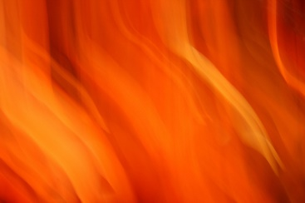

~ / ~

{ A symphonic artistry of production and creative direction, film runs on the various screens and scrims with audio montage. A booming voice announces the court to rise for the Judge’s entry. }

VOICE OF THE JUDGE

The Turkish High Court is now in session and will preside in the matter of . . .

“The State of Turkey vs. Urbana Magellan for the murder of Yaram Karadam.”

VOICE OF THE PROSECUTOR FOR THE STATE OF TURKEY

Your Honor and the Court, we will prove here today that the defendant, Urbana Magellan . . .

{ As he continues, Urbana begins to rise from under the stage on a pedestal, a woman accused of murder preparing to boldly face her all men judges and court in striped prisoner's uniform.

Slowly the pedestal rises until it is high above and in the middle of the stage. It is an old fashioned witness stand - Joan of Arc - preparing to be burned at the stake. The film running all around here - the stage ablaze in orange fire lights, crackling higher. So sexy it’s scary, she is in a black and white striped prisoner's uniform. Her hands are cuffed in front of her, no hair showing. Just Urbana with a hat - bending over - head bowed - while the Prosecutor recites her crimes aloud. It is a very special hat. A proud hat. A hat like this man is wearing.

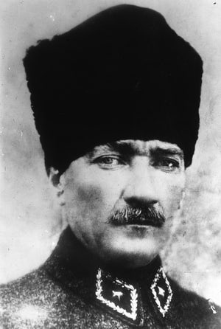

~ Mustafa Ataturk ~

{ Urbana slowly lifts her head up to face the audience. She removes her hat. She is bald. }

VOICE OF JACQUES DAVID MAGEN

“Your Honor, if it may please the court, my client, Urbana Magellan, she pleads . . .”

URBANA

{ A great wounded cry of an animal hurt beyond comprehension }

Ayeeeeeeiiiiiiiiiiiiiiiiiiiiiiiii!!!!!!!!!!!!!!!!!!!!!!!

The judge bangs his gavel for silence!

VOICE OF THE JUDGE

Silence!

Order!

Order in the Court!

The Defendant will be quiet!!

{ The gavel bangs repeatedly.

The protesters grow louder.

Both sides of the screens and scrims are filled with films of street protestors.

The Court is beginning to descend into chaos }

VOICE OF THE PROSECUTOR FOR THE STATE OF TURKEY

Your Honor! This is an outrage!

VOICE OF THE JUDGE

Silence!

Order!

Order in the Court!

VOICE OF JACQUES DAVID MAGEN

Your Honor! If the defendant may speak!

{ Under, over, and through the sound and visual montage is a operatic blend of

EMEGE EZGI – ADIM DENIZ

<https://www.youtube.com/watch?v=NTrPXW-Ncj4>

&

ELANA CERNEI, CAMILLE SAINT SAENS SAMSON ET DALILA

<https://www.youtube.com/watch?v=PpSGQPdmjnk> }

URBANA

My name is Urbana Magellan.

I am a child of Ataturk . . .

I believe in fundamental universal human rights –

Regardless of gender, race, faith, no faith, nation, or culture.

I believe in secular democracy.

I believe in the innate goodness of every human being.

I believe all this with every fiber of my being.

In the matter of promoting and protecting my fundamental human rights,

I plead . . .   
  
Do you love me ?

Do you think I’m pretty ?

Beautiful? Haunting? Tragic? Redemptive?

Honorable?

VOICE OF THE JUDGE

Silence!

Order!

Order in the Court!

The Defendant will be silent!!

URBANA

I will NOT be silent!!

My name is Urbana Magellan!

I am a child of Ataturk!

I believe in fundamental universal human rights!

Regardless of gender, race, faith, no faith, nation, or culture!

I believe in secular democracy!

I believe in the innate goodness of every human being!

I believe all this with every fiber of my being!

In the matter of promoting and protecting my fundamental human rights . . .

I plead! I plead! I plead . . .

GUILTY!

GUILTY AS CHARGED!!

{ An explosion is heard. Fog begins filling the air. Lights flicker. Screens blink. Pop }

Slowly Urbana’s pedestal is lowered down from on high . . .

ELANA CERNEI, CAMILLE SAINT SAENS SAMSON ET DALILA

<https://www.youtube.com/watch?v=PpSGQPdmjnk> }

Urbana vanishes below as each of the screens grow dark, one by one.

________________________________

~ / ~

End of Act II, Scene III

{ Curtain }

~ Finis ~

♛